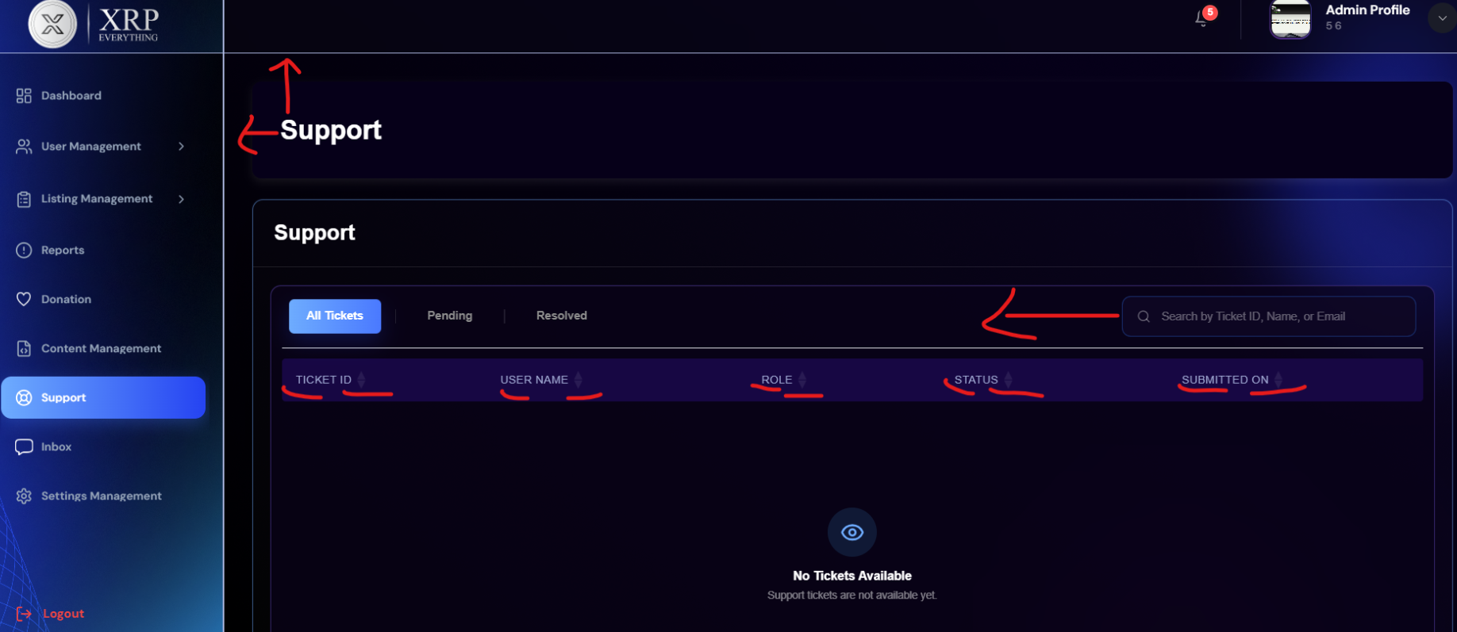
Support alignment issue
filter not working
backend issue

